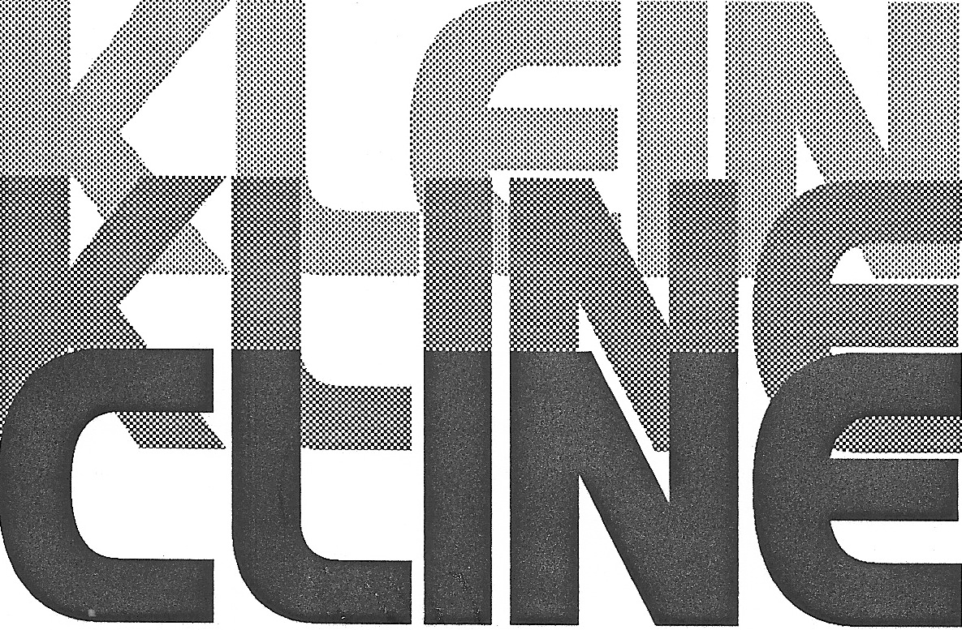
1992 Cline Reunion
at Lenoir-Rhyne College, Hickory, NC

by Metaleen Cline Morgan Thomas
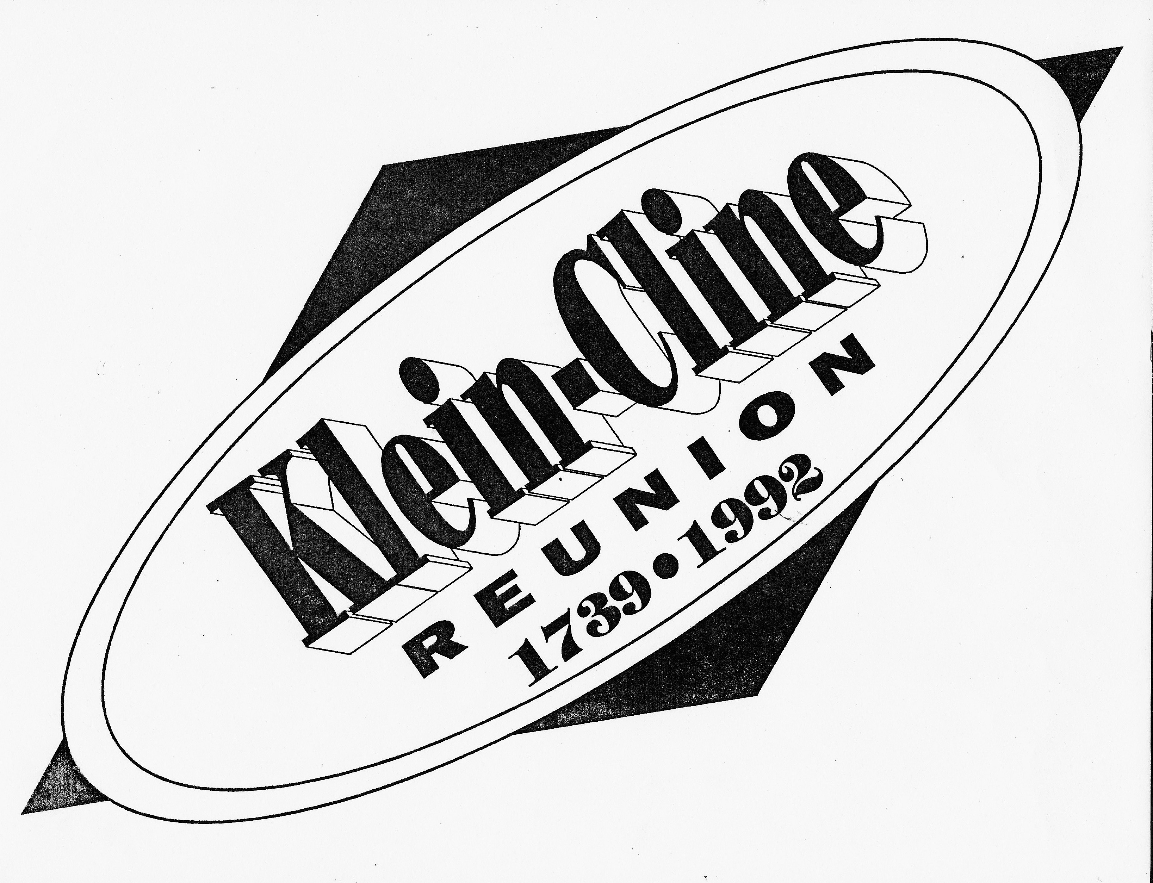

The 1992 Cline reunion was held on a Saturday and Sunday, June 27th - 28th at Lenoir-Rhyne College, Hickory, NC. One reason for this choice of locations is that Rev. William Pinckney Cline was one of four founders of the college. Our meeting was adjacent to the Founders Room with his portrait hanging on the wall. According to my notes from that reunion, we had about 100 people attend from 6 states: GA, SC, FL, VA, and NC. We sold all 30 newly designed Cline t-shirts– printed with the logo drawn especially for that reunion (see insert). Mike Gentry had this logo drawn especially for this reunion, using the dates 1739 - 1992.

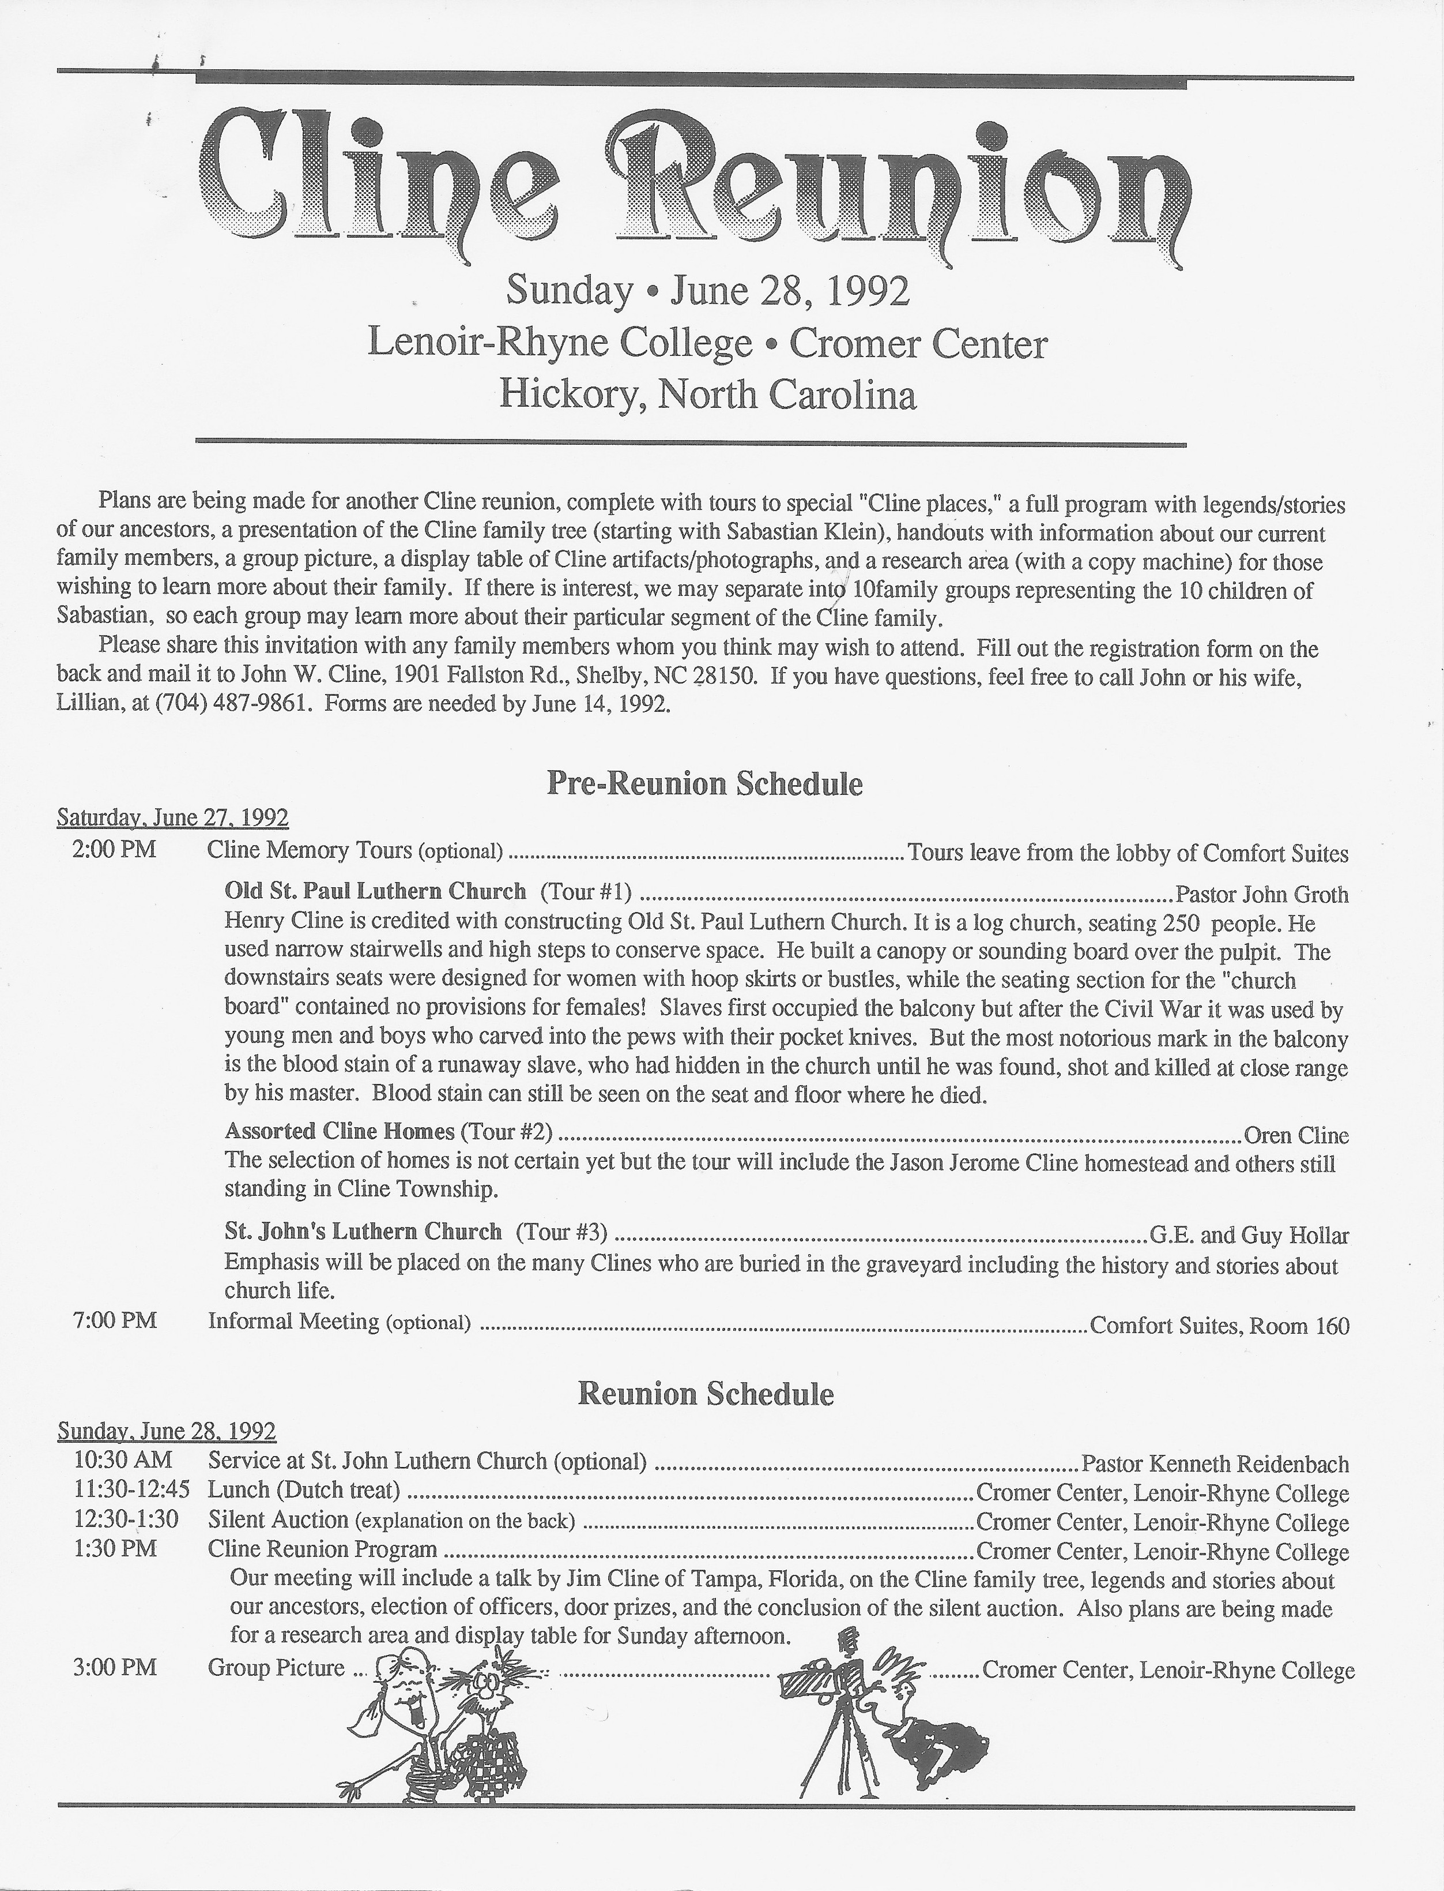
The invitations with the registration form (see inserted pages) were to be mailed back to John W. Cline of Shelby. He and wife Lillian chaired this reunion, and worked on every aspect of this event alongside Metaleen Thomas. We were essentially a 3-man committee. We gave out packets that year containing:
- The agenda with information about the display tables, the silent auction, the research table (manned by Col. Jim Cline and Mary Frances Smith), the group photo, a videotape available of the reunion, and the sale of special Cline t-shirts
- A copy of our growing Cline mail list (database)
- The 1992 reunion expenses (total cost of the reunion = $350)
- An evaluation form
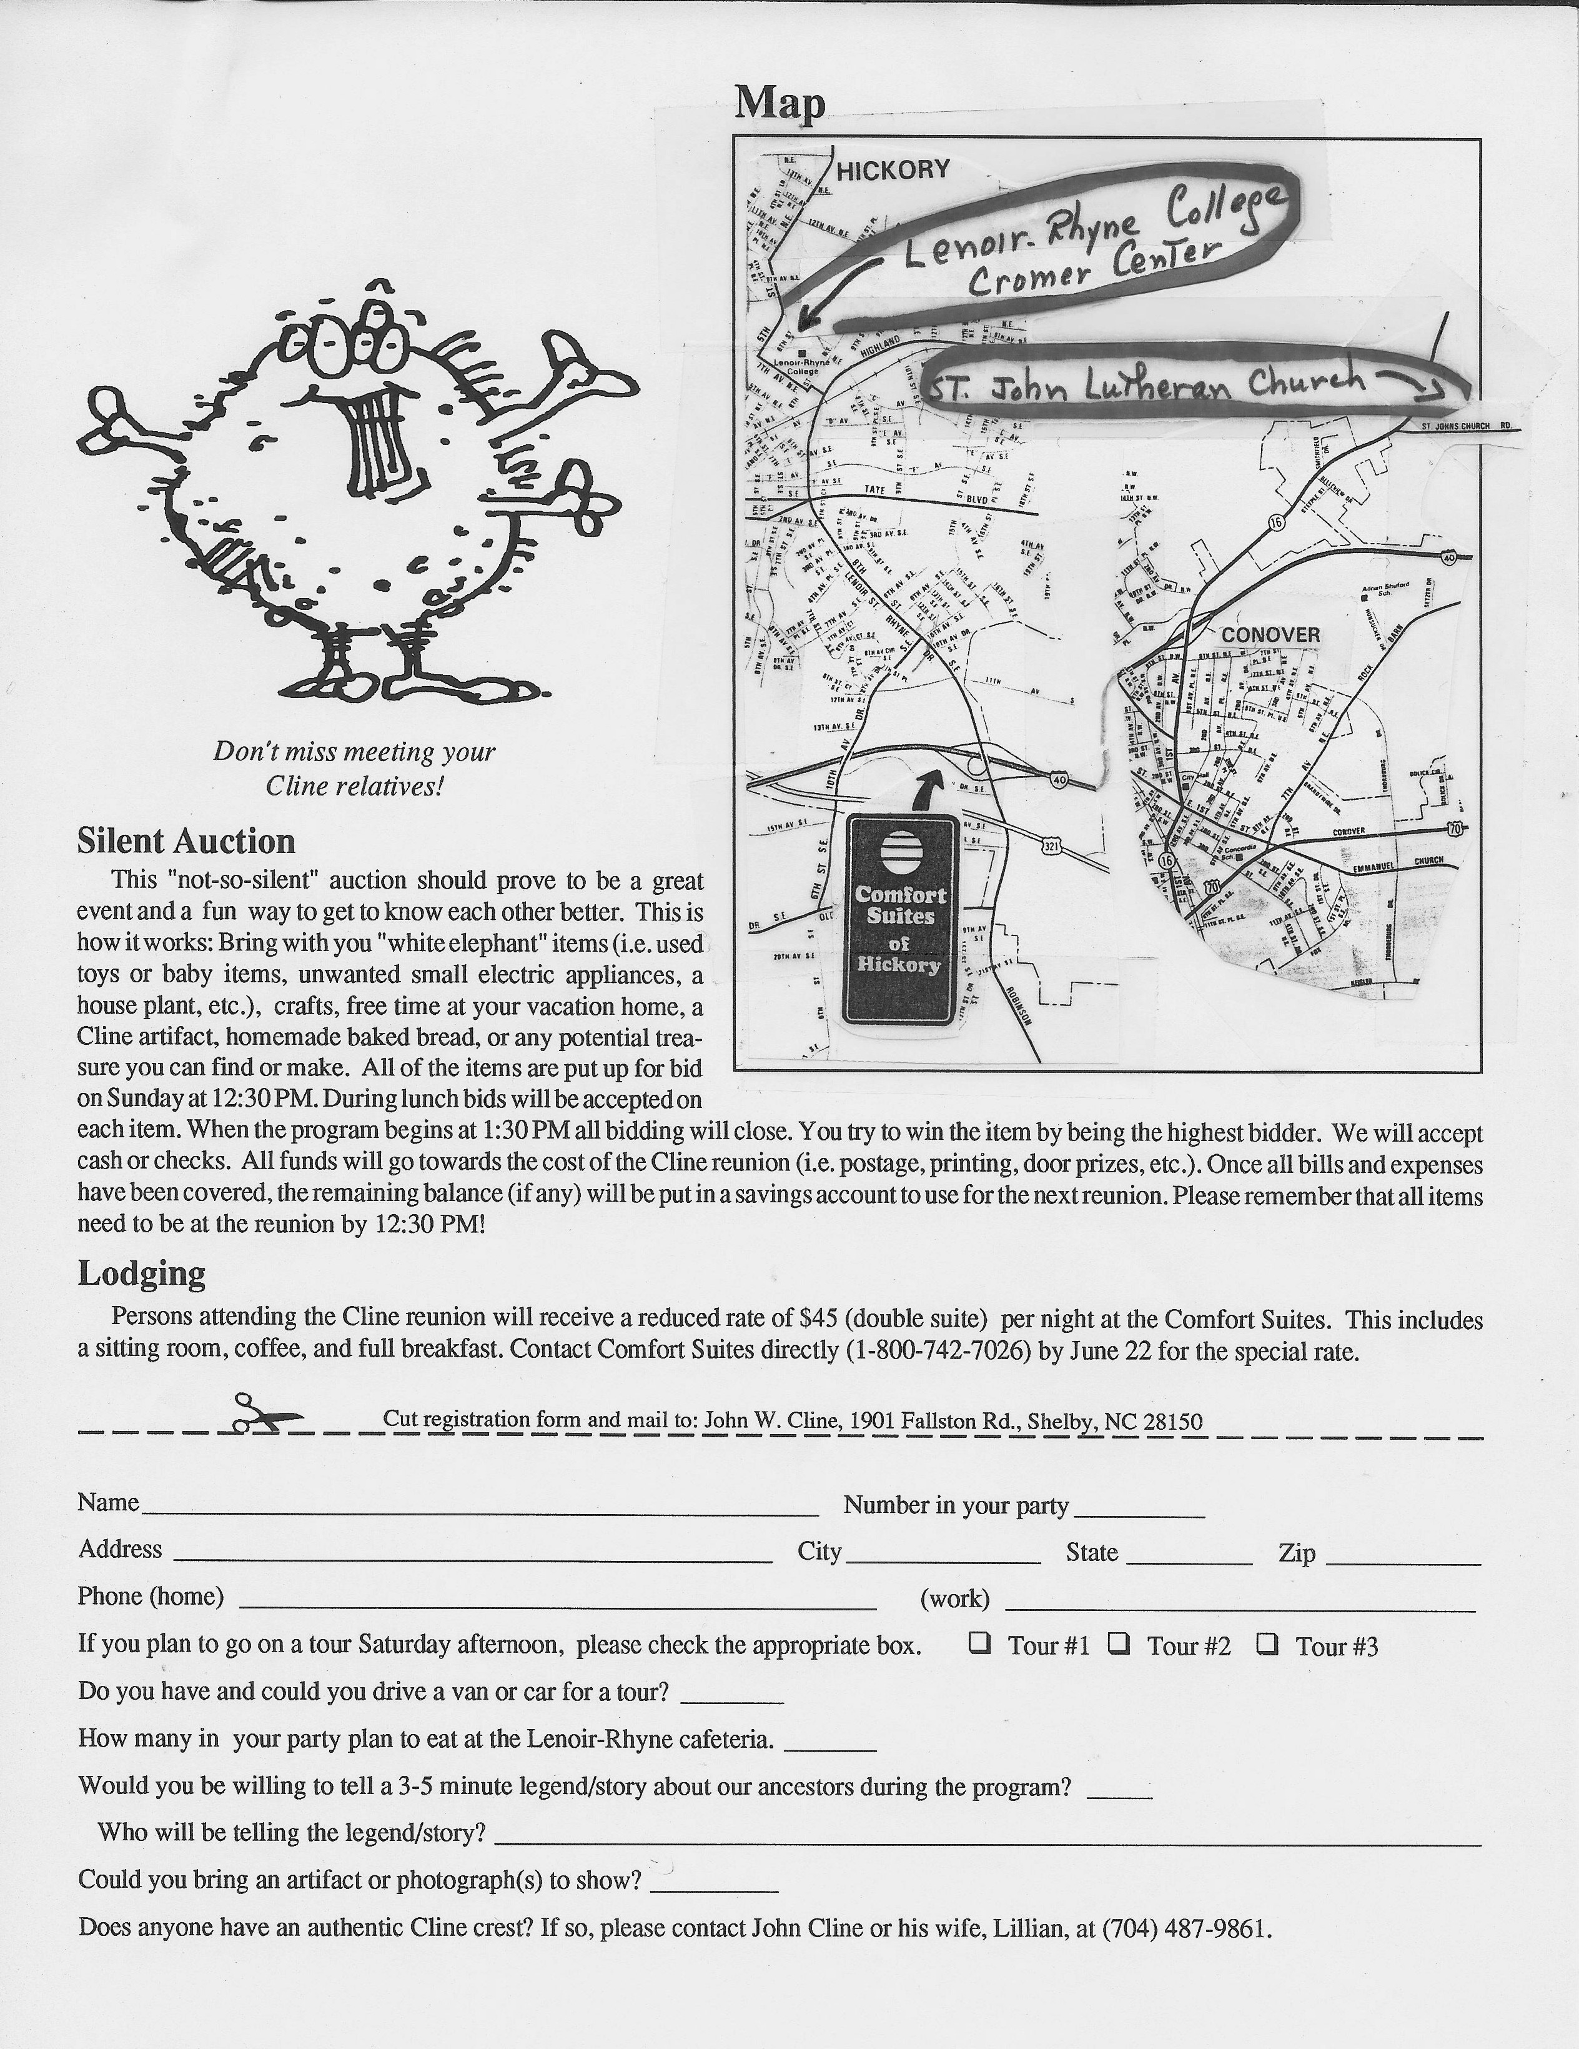
- A list of people & addresses that had been lost (invitations that were returned)
- A form for updating personal information for the database (new addresses, additions)
- A blank pedigree chart

This reunion started on Saturday afternoon with three separate tours to (1) Old St. Paul’s Lutheran Church in Newton, (2) Assorted Cline homes in the county, and (3) St. John’s Lutheran Church in Conover. That night, there was an informal reception at Comfort Suites (the designated motel).

Sunday began with church services at St. John’s Lutheran Church in Conover, followed by lunch in the Lenoir-Rhyne’s cafeteria (Dutch treat). Sidney Halma, Executive Director of the Catawba County Historical Society, gave a talk as did Col. Jim Cline of Florida. Several people told family stories before the results of the silent auction were announced. A new set of officers were elected for the 1994 Cline Reunion, headed up by Oren Cline. They also decided to invite Dr. Gary Freeze to speak at their 1994 reunion.

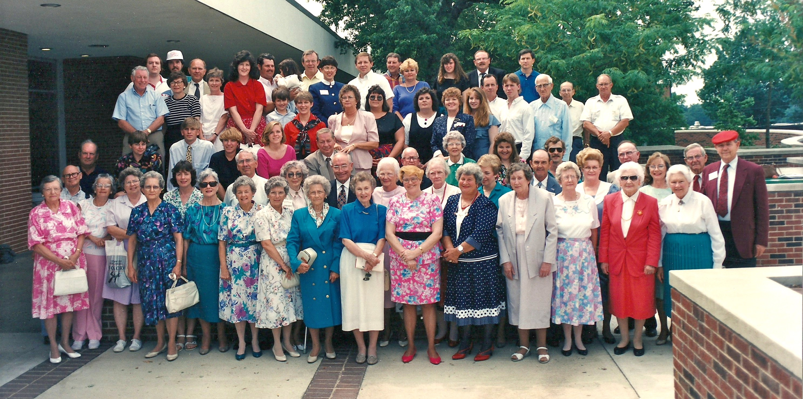
One historical note: Charles Robert Cline of Newton shared that he was putting a Cline family tree into a computer and wanted information on our families. In 1998, six years after this reunion, he printed the expanded edition of Ciscero Cline’s history. Ciscero was his great grandfather.

